A Web-based Business Management System for Fudz Enterprises

Student No: 100949

n Information System Proposal Submitted to the Faculty of Information Technology in partial fulfilment of the requirements for the award of a Business Information Technology

Date of Submission: 27th January, 2021

# Declaration

I declare that this work has not been previously submitted and approved for the award of a degree by this or any other University. To the best of my knowledge and belief, the research proposal contains no material previously published or written by another person except where due reference is made in the research proposal itself.

Student Signature: 100949 Date: 3rdJune,2020

# Abstract

Fudz Enterprises is one of the small outside-catering business in Kenya. They cater for small to medium-scale events and get new clients through word of mouth and references. The biggest issue that the company has, is data management and inventory management. Data gained from any source such as clients is stored in books or paper which is easily lost or destroyed which makes it very hard to get comprehensive reports because they only use what they have on hand. Inventory management is also paper based. This brings about an issue where when the inventory data is lost or incorrectly input, it could skew the expectation the company has for providing service. These small inconsistencies make inventory management very hard, requiring constant counting and recording of the results then repeating the same every time the data cannot be found or trusted. Several companies have already created different solutions to help such catering companies. The solutions, however, seem not to be targeted for small-scale outside catering businesses due to the high monthly charges and inclusion of modules that these companies may not use now and would never use. The solutions are, therefore, too much of an expense especially since they would require too many configurations to meet the need of the smaller companies which would even make it more costly to the business. This project seeks to fix the problem that companies such as Fudz Enterprises are having by making a cost-effective web-based management system that would allow them to manage their data and inventory easily and would only have the modules they would need. The project has been developed using Object-Oriented Analysis and Design and the Extreme Programming methodology.

Table of Contents

Declaration ii

Abstract ii

List of Figures iv

List of Tables v

List of Abbreviations vi

Chapter One : Introduction 1

1.1 Background 1

1.2 Problem Statement 2

1.3 Aim 2

1.4 Specific objectives 2

1.5 Justification 3

1.6 Scope/Limitation 3

Chapter Two : Literature Review 1

2.1: Introduction 1

2.2: A description of the operations of the catering business 1

2.3: Problems faced by Fudz Enterprises 2

2.4: A review of the current business management information systems 4

Chapter Three : Methodology 1

3.1: Introduction 1

3.2: Extreme Programming Methodology 1

3.2.1: Planning Stage 2

3.2.2: Designing Stage 2

3.2.3: Coding/Development Stage 3

3.2.4: Testing Stage 3

3.3: Design 3

3.4: System Development Tools and Techniques 3

3.5: Testing methods 4

3.6: Domain of Execution 4

Chapter Four : System Analysis and Design 1

4.1: Introduction 1

4.2: Requirements Gathering. 1

4.3: System Requirements 1

4.3.1: Functional Requirements 1

4.3.2: Non-functional Requirements 2

4.4: System Architecture 2

4.5: Analysis and Design 2

Chapter Five : System Implementation and Testing 6

5.1: System Implementation 6

5.2: System Testing 6

Test Environment 6

Test Cases 6

Test Results 7

Chapter Six : Conclusions, Recommendations and Future Works 1

Conclusion 1

Recommendations for Future Work 1

References 2

Appendix 3

Time schedule (Gantt) 3

# List of Figures

Figure 3.1: Extreme Programming Lifecycle Diagram 2

Figure 4.1: Use case Diagram 3

Figure 4.2: Class Diagram 4

Figure 4.3: Sequence Diagram 4

Figure 4.4: Entity Relationship Diagram 5

Figure 4.5: Database schema 5

Appendix A.1: Gantt chart 3

# List of Tables

Table 5.1: Test Cases 19

Table 5.2: Test Results 19

# List of Abbreviations

CRM – Customer Relations Management

ERP - Enterprise Resource Planning

GUI – Graphical User Interface

OOAD - Object-Oriented Analysis and Design

XP - Extreme Programming

WAMP – Windows, Apache, MySQL, and PHP

# : Introduction

## Background

The Catering business is based upon providing clients with food and drinks for their occasions (Shaikh, A., Singh, A., Walawalkar, G., & Kapasi, F., 2019). Though food is the main business, they can provide décor and utensils among other things. Fudz Enterprises is a small-scale family run business based in Nairobi Kenya. They deal with providing food, décor, and utensils for a client’s occasions. This includes providing cutlery, tablecloths, napkins, and drinks among other things as determined by a contract signed by the client about what they expect the business to deliver.

Most catering businesses that are small scale face the same issues regarding the management of the business data. The business utilizes a manual method of storing all the data that they gain (Ahmad, 2018). This is done by documenting data on paper which at times may be lost or lose relevance due to loss of other data associated with it. This method of keeping data is quite error-prone since it relies on the legibility of the writing to the accuracy of the information given to the person documenting. It also has a higher rate of redundancy since some data is repeated frequently to help counter the issue of loss or destruction of the paper.

Due to the small size of the company, they deal with keeping contact with clients through phone calls and the data is stored in a book for the catering. They also must keep track of their inventory using pen and paper which is tedious since the records are not permanent and require a fresh record every catering to be able to keep track. This presents an issue where when the data is lost, the reports become useless since there is no reference data to compare to get the best information. This information can be used to figure out several things including the most prevalent occasion and the most chosen food item and drinks. This analysis of data can only be done when data is present which is not often the case with a paper-based data storage method. There are many other established business management systems to be used but the company is too small to justify the use of such specialized systems which are expensive to purchase and maintain (Shaikh, Singh, Walawalkar, & Kapasi, 2019). Therefore, a custom system is better for them and the proposed system provides the business management functions that would better meet the business needs in a cost-effective way of storing, managing and reporting on the data stored as well as providing the company with the means to accurately manage their inventory.

## Problem Statement

The current system is ineffective to be used if the company seeks to grow its client base (Ahmad, 2018). The current process is very error-prone due to the need for handwritten reports and frequent use of paper which is easily destroyed or lost. This leads to a loss of critical data which is needed by the company (Shaikh et al., 2019). The current system leads to inaccurate assessment of the number of items they have like plates and cups due to poor inventory or the loss of the records which may lead to extra costs of trying to hire or buy the items to fulfil a client’s request. Another issue faced is the storage of client and employee data for the long term. Since most data is documented on paper, the chance to lose critical client data (Shaikh et al., 2019) is higher which means a loss in the company’s ability to analyse trends, for example, to see what food item or drinks clients mainly pick for a menu, in a certain ceremony.

## Aim

The aim of this project is to develop a web-based management system for Fudz Enterprises to solve the problems outlined in section 1.2. The system seeks to solve the problems by providing the company with a cost-effective means to store the data they get and be able to manage their inventory by using a web-based system. This would help in the creation of comprehensive reports that they can use for business decisions in a reliable, time-saving, and cost-effective way.

## Specific objectives

1. To study the methods used by catering businesses to manage data and inventory.
2. To review currently available systems used by larger catering businesses to find out why they are not used by smaller businesses
3. To design the management system for Fudz Enterprises
4. To develop the web-based management system for Fudz Enterprises.
5. To test the developed system.

## Justification

This project seeks to solve an issue that many other systems have not been able to, and that is to provide a cheaper alternative to the record-keeping and inventory systems in the market. Since most of the systems made and available in the market are made for larger companies which means they are more expensive and require specially trained people to run and maintain the system which would be an unnecessary expense for the smaller companies which would benefit from such systems and even if the system was specially customized, the cost would be higher since the companies are smaller and the company would essential just make a limited version of their application for the companies.

It has been specifically made for the company which means that the setup would be faster and would apply to the business better than the other systems in the market. This is because the company’s business structure would be taken into consideration when making it and would be able to be integrated easily since it was custom built for the company.

## Scope/Limitation

This project has a record-keeping, inventory management and basic reporting component. It is be a web-based system, but it has no means for a client to provide their details through it. It has been restricted to access by employees of the business for data input and report generation as well as the output of inventory levels. It also includes a database for the storage and retrieval of the data stored. This system does not include a comprehensive reporting and prediction system due to time constraints.

# : Literature Review

## 2.1: Introduction

This chapter shall cover the research and review of existing information about the outside catering business and all the current solutions and systems created to solve various problems faced by the businesses. It will seek to find information to better bring out the issues faced by small outside catering businesses and what solutions are used by larger companies to solve them. It will also seek to provide an insight of why the proposed solution is required to fill the gaps left by the current systems.

## 2.2: A description of the operations of the catering business

Catering is a service-based food and hospitality business with a focus on providing food services for events and other needs for a client. It can be segmented into three different parts: Commercial segment, non-commercial segment, and military segment (Shiring, Jardine, & Mills, 2001). This segment is used to show where the focus on service delivery is. In the commercial segment, we have off-premises catering/outside catering which is the focus for Fudz Enterprises. In outside/ off-premises catering, it is the caterer’s job to prepare, cook and transport the food to the venue including all the equipment and drinks (Shiring, 2013). This catering type requires critical planning and management to ensure everything is done correctly and to the client’s specification. This is because it is the caterer’s job to perform certain tasks such as surveying the event site, meet the client’s specifications and requests, manage the time for preparation, delivery and setting-up time while ensuring the quality of the meals and service (Shiring, 2013).

When a client meets up with an outside caterer like from Fudz Enterprises, they discuss the details of the event. The details are the number of people expected, type of event, any special requests about the meals or the décor, among others. When the discussions are done and the caterer has accepted, the client will outline what the menu they would want, and the caterer would draft it for approval. They can provide suggestions of what to cut and add to the menu depending on pricing of ingredients, appeal and what is most popular. After the menu is finalised and the client approves, the caterer would provide a detailed costing and the final menu. This costing will have cost for ingredients, equipment, labour, and transport. This costing is very comprehensive and can be used to re-evaluate the menu if the cost is above the client’s expectation. A contract will be drafted, if the costing is accepted, that will detail the payment and service delivery for the client and caterer, respectively.

The caterer will need to coordinate with any other personnel in charge of the venue to secure any needs they require. These needs could be an electrical outlet, place to equipment safely away from the view of the guests and the details about table placements and serving station placements with relation to specific factors like nearness to water supply for washing the dishes (Shiring, 2013). This is crucial since it will be in line with any needs of the clients as well as making the work more comfortable for the caterer and their staff. Depending on the caterer’s business model, that is if the caterer has employees or hires them per job, they will need to prepare all the requirements for the event which include ingredients to be used, equipment like cookers and chauffing dishes used to hold food for service. During the event day, the caterer will be expected to cook food, prepare all the cutlery then transport the food to the venue. The cooks and waiters will be expected to help with food service while the caterer manages and supervises the exercise. If things go according to plan, the food will be sufficient to feed all the guest well, the caterer will then clear up with the help of their employees, load all the equipment and any other thing they brought and perform an evaluation of the equipment at their workplace or storage area to ensure that the numbers are exactly what they brought. The caterer will pay the contractors after they receive the money for the job. This is what Fudz Enterprises does when it is given an event to work.

## 2.3: Problems faced by Fudz Enterprises

The issues that Fudz Enterprises can have come from three different areas. These are the client, data management and unexpected outcomes. Unexpected outcomes account for most of the issues that an outside caterer can get (Shiring, 2013). Some of these unexpected outcomes can be like traffic jams, change of weather or issues with contractors. These outcomes are not easily mitigated and are at times impossible to predict if or when they will occur. The only way to try and overcome them is by planning very well. An example is planning transportation at times when there will be no traffic jams or having backup plans in regards with the contractors. While this does not ensure they will never happen, it will help in avoiding some of them and having backup plans for the ones that cannot be avoided. Therefore, adapting to the situation and making the best of every situation along with a concrete plan is needed for an outside caterer (Shiring, 2013).

Second problem area is at the client’s side. Though it can be thought that it is not particularly an issue for the caterer, it is the caterer’s job to provide for the client regardless of the unintentional obstacles the client may place. Exceeding the client’s expectations is one of the goals each caterer should have but this introduces a new level of pressure (Shiring, 2013) since the caterer will need to work very efficiently to produce this outcome. An example of some of the issues caused by the client is providing wrong figures about the guest turnout.

The guest turnout is used to provide a base for food, drinks, cutlery, and staff the caterer must provide for the event. Poor estimates on the number could lead to either too much food being produced or the most likely event being too little food being produced. Cutlery and the staff can be easily sorted but food and drinks cannot be easily remedied since they are prepared beforehand. Rationing of serving can be done but it may not be enough, leading to some guests not getting food or drinks. Overworking the staff, who are fewer than is required, is also an effect of the bad estimates since they must help the guests while making sure to pick up dishes, directing the guests and washing them since they were not enough for all the guests. This issue is not easy to solve since it is based upon the provision of correct information by the client. The best way is to emphasize the need for the correct number while ensuring that food, drinks, cutlery, and staff is planned for a higher number since it is better to have more of all of them than less.

The last problem area is the data management and inventory control (Luo, 2018). This is the area this project will seek to solve. One of the biggest parts of the business is the movement of items from one area to another. Therefore, the caterer must keep a list of all the items they have and will take. This is the packing list (Shiring, 2013). This list is a necessary part of the preparation since they need to keep track of the numbers of the equipment and any other items they will take and use at the venue. The issue comes after since while the list will be used, the data from the list is not stored in the most secured form since it is in paper form. This means that they may not have the actual numbers for their equipment when needed if the list is lost after the event. They, therefore, need to use previous lists or memorised numbers and figures. Inventory must be accounted for before and after every event since they do not have the means to evaluate the inventory other than manually counting. This leads to small errors in preparation especially if the inventory is not accounted for correctly which affects the preparation for future events. This could be effects like buying extra ingredients that are already there which leads to a loss or the opposite which is not buying items because it was thought to be there. Proper data management and inventory control need to be set up and the business would profit from using the proper technologies like business management systems (Luo, 2018).

## 2.4: A review of the current business management information systems

Business management systems are a set of policies, controls, procedures, and processes used in the development of strategies, running the business and all other management activities (“What Is Business Management System?” n.d.). These systems are further improved by the information systems which incorporate the business processes into an enterprise resource planning (ERP) system. An ERP system is a system that integrates all business functions to the system which allows for better planning and management of resource needs of the company by providing comprehensive reports from the database (“What Is Enterprise Resource Planning (ERP)?” n.d.).

Current business management information systems all have plenty of features and advantages that are very useful for business management. For a catering business, there are a couple of popular applications that can be used as an example (Ongudi, 2019). Flex Catering is the first in the article by Ongudi on the 5 best catering software in 2019. Flex Catering offers multiple different features that are very useful to a catering business. These features are available in different numbers depending on the plan they pay for every month (“Flex Catering Software | Professional Catering Management Software,” n.d.). Some of its key features according to Ongudi is their e-commerce which will allow for greater customer interaction by allowing them to better see menus among other things; both order and product management modules which help in the management of the business’s products and orders. They also include a CRM which helps customer relations and interaction with the business.

The issues found with Flex is that it is mostly built around hotel, restaurant management and on-premises catering. All the key features needed for Fudz Enterprises are there, but the cost to slim down the program would be higher than they would be willing to pay. This is because the lowest plan they have, also has a lower user count, and contains many modules that are not usable by the company. This is also applied to all the other software where the cheapest quote for the software monthly is $69(“Better Cater | Simple Catering Software | Award-Winning | Free Trial,” n.d.).

The cost of these software as compared to the benefits they will provide are not enough because the business model does not have a reliable way to get work every time. Most events are planned weeks in advance and due to the small size of the company they can only accommodate for 5 jobs per month depending on the size of the events. The larger the size of events, the least the number of events that can be catered for in the month. It is also dependent on seasons and the weather since most people have more events when the weather is much more conducive for gatherings. This means when it is not raining and during holidays. This inconsistency of work makes the monthly payments for software they may not make use of every single moment, very expensive.

# : Methodology

## 3.1: Introduction

A methodology is a framework that details the processes that will take place during the system analysis, development and testing will be done. It is used as a guide for developers to ensure the systems developed are to the standards needed (Hutagalung & Sauter, 2006). This project used the Object-Oriented Analysis and Design as the software development framework with Extreme Programming (XP) as the methodology used. This is because it allows the developer or team to create modules multiple times to ensure that the module works as intended. Extreme Programming is very useful when dealing with a strict timeline allowing for work to be done efficiently. This is because it emphasizes dealing with features that are needed only allowing for the developer or team to have a boundary on what they should do at any point.

## 3.2: Extreme Programming Methodology

Extreme Programming is an agile software development that utilizes an iteration method of software development which is very beneficial (Sergeev, 2016). This is because it allows the developer or team to create modules multiple times to ensure that the module works as intended. Extreme Programming works with the principals that each system development needs to be simplified, all features implemented need to be needed by the client and testing is done on every iteration. This makes it very good for projects that need a lot of customer interaction and those with strict timelines since its emphasis on feature control helps. It has four stages of the methodology which are repeated until the project is done. These are Planning, Design, Coding/Development and Testing (where the customer’s impression are used together with other testing methods)

*A close up of text on a white background

Description generated with high confidence*

Figure .: Extreme Programming Lifecycle Diagram

Sergeev, A. (2016, May 23).

### 3.2.1: Planning Stage

In the planning stage, the developer is meant to get all information about the project from the client. To be able to develop this project, the requirements and specification are needed to figure out what modules are needed for it to work as the client intends. Documents review was performed to find out what kind of reports the client needs and uses. Other information gathering methods such as observation and interviews were used to get information on how the company functions and how the client expects the project to be.

### 3.2.2: Designing Stage

The Design stage is the point where the developer/ team starts to identify how the project will look like. The modules that were identified during the planning stage, were represented using design tools such as use cases and schemas to plan out how the project will look like. The module interactions were represented, and the information gained about the modules was used to decide what order to be used during development. The information gained from the planning stage was used to gain an understanding of how the features should be implemented and was used to make the structure that was used as a guide for development.

### 3.2.3: Coding/Development Stage

The coding stage is where all the designs are implemented, and the coding of the modules begins. The code used was simple and easy to follow since the project needed to be reviewed multiple times to allow for easy debugging and refactoring. During this stage, version control systems like GitHub was used to provide backups in case of issue with the project while providing reliable version control. Frameworks such as Codebase for the user interfaces and using Laravel, which made the development of the web-based system.

### 3.2.4: Testing Stage

The testing stage is where the prototype project will be tested and sent for the client acceptance test. The project was checked to ensure that the system requirement was met, and it functioned as needed by the client. The acceptance test was used to check whether the project was able to meet the requirement that the user had. Using the details gained from this, the process was repeated from planning until the deadline is reached.

## 3.3: Design

System design is the stage of the system development where the developer creates a guide for how the project will look. This is usually done to present to the client and use it to explain how the project will function. Since this project used OOAD, there are specific design diagrams that are to be used to perform the system design. These are: Use case diagram, class diagram, sequence diagram, database schema, GUI design diagrams/wireframes/mock-ups. The use case diagram is used to define the interaction of the users, the code base, and the database where it shows how the data flows depending on an event. The class diagram describes the blueprint used when creating the objects. This is used to show how the system has be broken down with which class acting as a specific function. The sequence diagram shows object interaction in an event arranged according to a time sequence. The database schema is used to show the place where everything is stored in the tables.

## 3.4: System Development Tools and Techniques

This project used specific tools and techniques to develop it. These tools are MySQL Workbench and WAMP for the database creation because of how comprehensive they are and since they allow for easier creation of the database, Sublime Text and PhpStorm have been used to write the code base, Laravel has been used as the framework for the development due to its ease of development of the websites with the Codebase Template for the interfaces and UI elements since it makes the creation of pages very simple with a lot of inbuilt functionality. Finally, GitHub to act as a backup and versioning tool when necessary to avoid the complete loss of the project progress due to numerous issues that can happen during development including a corruption of the files and the deletion of crucial information.

## 3.5: Testing methods

Testing is done during and after development to ensure that the system is working as intended. These methods that would be used include unit testing done after every module is completed to ensure that it is working as needed, integration testing which will be done after all modules are done to ensure that the modules work well together, and no error is formed from the integration of the modules. White box testing will be done to make sure that the system can work on any computer without issues if the computer is configured to match the development computer. Finally, an acceptance test by the client to see if the project worked as they requested or presented to them.

## 3.6: Domain of Execution

This project’s domain of execution is web-based. This is because of the freedom that it provides for the creation of data dependent systems without the issue of storage on the client’s computer. This is also done since the project could also be extended to a website which would further complement the system. Due to extension possibility and the storage issues, it is better for the system to be web-based.

# : System Analysis and Design

## 4.1: Introduction

This project shall utilize the Object-Oriented Analysis and Design (OOAD). This is because it allows for the planning of the project in a modular format. This allows for easier development of the features required while increasing the quality of the modules created. This emphasizes breaking down the project into parts then joining them later. OOAD also allows for iterative methodologies which makes it better when paired with Extreme Programming.

## 4.2: Requirements Gathering.

Requirements gathering is a process done during systems analysis that deals with finding out the parts or goals set for a system to achieve. The requirement gathering process used to get the requirements for this project were:

Reviewing documentations and other details from Fudz to get an understanding about how the system should operate.

Reviewing other systems in the market to figure out what this project should seek to achieve.

Conducting interview with the manager of Fudz to get an understanding of the details they need to record and get their thoughts on how a system should work to help them.

## 4.3: System Requirements

System requirements are a set of goals set by the client or a systems analyst for the creation of the system according to their specification. They are used as a guideline for what is to be expected for the system to be functional. They are divided into two:

### 4.3.1: Functional Requirements

A functional requirement is one which must be present in the project for the project to work. These requirements act as the features and modules needed for the system to be complete. This project has the following functional requirement:

FR1- The system must allow a user to register and login to the system.

FR2- The system must allow a user to register and login to the system.

FR3- The system must be able to provide the user with a means to input data to the system. The system must also take inventory and other data and store them.

FR4- The System should allow a user to edit a record.

FR5- The system must be able to output all the data it has stored. This requirement deals with the output of data stored in table form and as a simple report.

### 4.3.2: Non-functional Requirements

Non-functional requirements are those that do not define the structure of the system but are necessary for the improvement of the system. The non-functional requirements are:

NFR1- The system should be secure. This means that only authorised users can access any data stored.

NFR2- The system should also be user-friendly. This means that the system is easy to learn for a new user and easy to use.

NFR3- The system should also be reliable. The reliability of the system means that the system can be able to recover from downtimes fast and without loss of data.

## 4.4: System Architecture

This project has two major components. These are the data management component and the inventory management component. In the data management component, Users module is used to review users. The data input module for various things like employee details, client details, event details, finance details, menu details and the packing list details in a form. The data output module uses a table format for the things mentioned. The inventory management component deals with the company’s inventory. The items input module will allow the user to input new items to the inventory database and update the number of the items in the inventory. The inventory control module displays the company’s inventory and show the specific numbers of items since the last update. The module can be affected when the packing list is generated. Finally, the reports module is used to provide reports to the user from the inventory and data management components.

Users

Data input

Data output

Inventory

Data Management

Reports

Figure .: System Architecture

## 4.5: Analysis and Design

System design is the stage of the system development where the developer creates a guide for how the project will look. This is usually done to present to the client and use it to explain how the project will function. Since this project uses OOAD, there are specific design diagrams that are to be used to perform the system design. These are: Use case diagram, class diagram, sequence diagram, database schema, GUI design diagrams/wireframes/mock-ups. The use case diagram is used to define the interaction of the users, the code base, and the database where it shows how the data flows depending on an event. The class diagram describes the blueprint used when creating the objects. This is used to show how the system is broken down with which class acting as a specific function. The sequence diagram shows object interaction in an event arranged according to a time sequence. The database schema is used to show the place where everything is stored in the tables. The stated diagrams are as seen below:

Figure .: Use case Diagram

The diagram above is the use case diagram which is used to design a proposed system. It shows all possible actions that can be taken within this system

Figure .: Class Diagram

The class diagram is used to show the interactions between the different proposed classes for this project. It shows the system’s potential interactions.

Figure .: Sequence Diagram

A sequence diagram is used to show how processes in the system flow through. They represent the start till end of a process.

Figure .: Entity Relationship Diagram

The entity relationship diagram is the diagram used to represent the potential relationship between the key areas of the project like between the catering and a client.

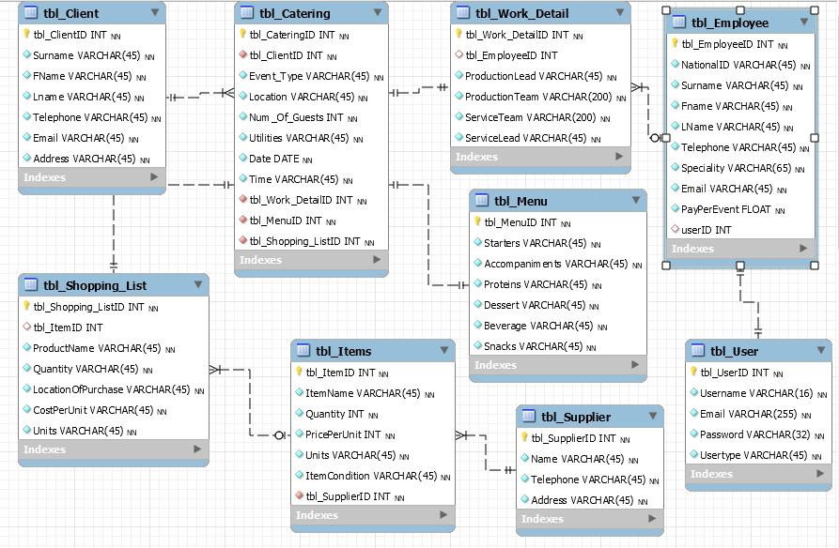

Figure .: Database schema

Finally, the database schema was used to represent how the database would look. It shows the data types proposed and used in the system together with the decided relations.

# : System Implementation and Testing

## 5.1: System Implementation

### 5.1.1: System Components

This project has two major components. These are the data management component and the inventory management component. In the data management component, Users module is used to review users. The data input module for various things like employee details, client details, event details, finance details, menu details and the packing list details in a form. The data output module uses a table format for the things mentioned. The inventory management component deals with the company’s inventory. The items input module will allow the user to input new items to the inventory database and update the number of the items in the inventory. The inventory control module displays the company’s inventory and shows the specific numbers of items since the last update. Finally, the reports module is used to provide reports to the user from the inventory and data management components.

### 5.1.2: Working of the System

The project requires several necessary programs and resources to create the environment to develop it. GitHub was used to store the project in an online repository which acts as a backup resource and version control. MySQL Server and WAMP for the database and providing PHP environment and PhpStorm has been used to write the code base and deploy the web-based system with Laravel as the framework for the development together with Node JS and composer to make the project. Codebase Template for the interfaces and UI elements which contains built in functionality for the web pages. The following pictures show how the system looks and functions:

The image below is the first page seen when the website is opened. It provides the user with the choice to register or login to the system.

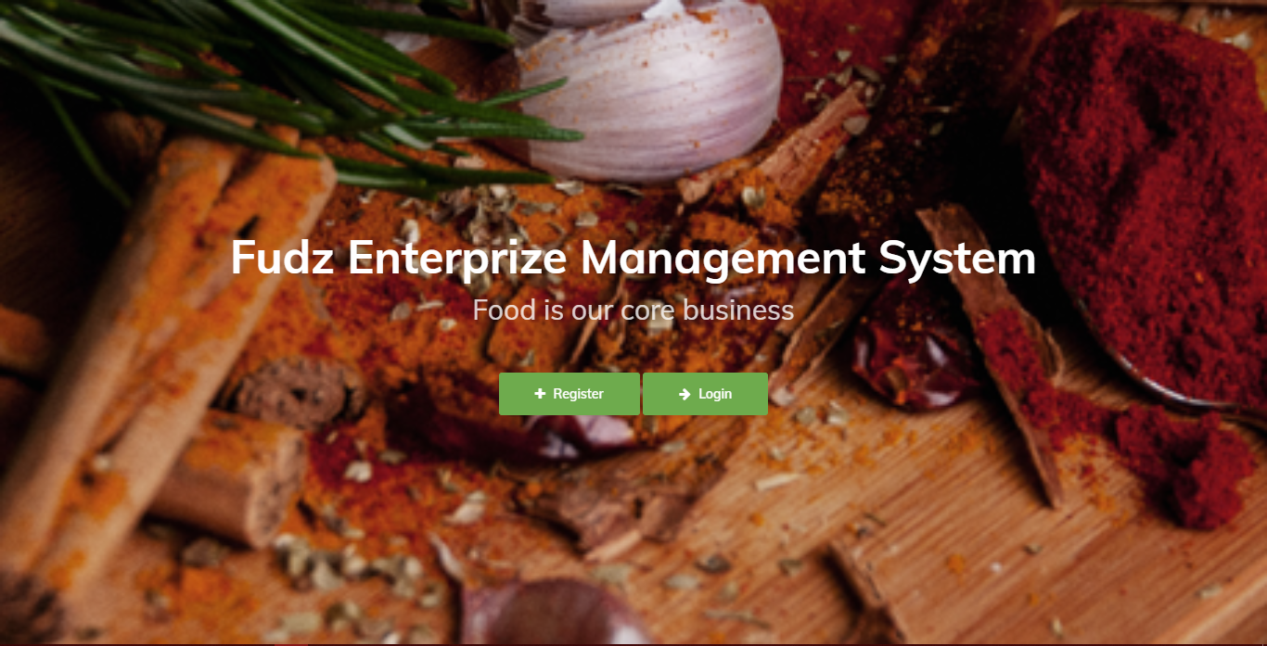

Figure .:Landing page

Figure .:Registration page

The image shows the registration page where the user can register for a new user account.

Figure .:Login page

This image shows the alternative option from the landing page. This is used to login if the user already registers.

Figure .: Homepage

This image shows the page both the registration page and login page lead to.

Figure .: Data Input page

This page is a sample data input screen while showing the side bar containing all other pages available.

Figure .: Data output page

Finally, this image is the sample data output screen and report screen.

## 5.2: System Testing

This chapter will show the several tests and the result of those test cases. This chapter will help ensure that the requirements specified will be properly executed. Test are used to make sure that the system runs as needed. The test environment will be specified to ensure that the future tests done get the same results. This makes it certain that if the system is run and retested in another computer with the same specification as the original test environment.

### Test Environment

The test environment is a HP EliteBook Folio 9470m with an Intel(R) Core (TM) i7-3667U CPU with a CPU clock speed of 2.50 GHz. The test computer has a RAM of 8.00 GB. The system utilizes a Windows 10 Professional operating system and has a system type of 64-bit operating system with a x64 bit processor. The screen size of the system is 14 inches with a screen resolution of 1366 x 768. The system utilises a MySQL server and PHPStorm IDE to deploy the website and utilizes Google Chrome to open the website.

### Test Cases

|  |  |  |  |  |  |
| --- | --- | --- | --- | --- | --- |
| **Test ID** | **Related requirement** | **Inspection check** | **Pre-condition** | **Test Data** | **Priority Level** |
| TI | FR1 | The system should allow a user to create an account. | The server should be running. | Use the following:  Username: Jason  Email:  Gikonyo.jason@strathmore.edu  Password: Testing123 | Medium |
| T2 | FR2 | The system should allow a user log in to the system with the correct credentials. | User should already have an account in the database and the database server should be running | Use the following:  Username: trial  Password: trialpasswrd | Medium |
| T3 | FR3 | The system should allow a user to input a new record into the system. | User should be logged in to the system and the database server should be running. | none | High |
| T4 | FR4 | The system should allow the user to edit the records | User should be logged in to the system and the database server should be running. | none | High |
| T5 | NFR5 | The system should allow the user to view the records and reports | User should be logged in to the system and the database server should be running. | none | High |
|  |  |  |  |  |  |
|  |  |  |  |  |  |

Table .: Test Cases

### Test Results

|  |  |  |  |  |  |
| --- | --- | --- | --- | --- | --- |
| **Test ID** | **Expected result** | **Actual result** | **Status** | **Recommendation** | |
| T1 | The system should allow the user to create an account then transfer them to the login page. | System allows a user to create an account | Pass | none. | |
| T2 | The system should allow the user to log in then transfer them to the homepage. | System allows the user to log in and prevents unauthorised access. | Pass | none | |
| T3 | The system should input the data and give acknowledgement. | Data was inputted but success is not shown | Partial pass | Add a message to show success. | |
| T4 | The system should display all the data stored. | Works as expected | pass | none | |
| **T5** | The system should allow the user to update and delete the records but not completely from the database | Works as expected | pass | none | |
|  |  |  |  |  |
|  |  |  |  |  |

Table .: Test Results

# : Conclusions, Recommendations and Future Works

## Conclusion

This project seeks to fix the problem that companies such as Fudz Enterprises are having by making a cost-effective web-based management system that would allow them to manage their data and inventory easily and would only have the modules they would need. This project is scalable by adding in modules as the company grows. During development, the time allocated is not enough to make a very complex system that could handle every aspect of the business. Therefore, certain areas of the business are not catered for. The system was then geared to a simple data management system with simple reports according to criteria already coded in the business logic. This could be an avenue for future changes and upgrades.

The project has been developed using Object-Oriented Analysis and Design and the Extreme Programming methodology. The use of object-oriented analysis and design allowed for much more dynamic development with easier addition for modules. This will benefit any additions in future. Extreme programming was utilized to the best possible way in the time allowed for development. Due to proximity and access to the business, the project is meant for allowed for easy consultation and referencing. Finally, the use of GitHub tremendously helped prevent the complete loss of the project progress due to numerous issues faced during development including a corruption of the files and the deletion of crucial information. This makes the repository a highly necessary resource that should be utilized every single project.

## Recommendations for Future Work

The system can be expanded to feature other modules: A graphical analysis using graphs, an accounting module can be implemented to handle the financial side of the company. More complex reports with more user agency. Better module relations with more linking of data affecting different forms.

The system can also be expanded to have a link to a website. Currently it is only a manager sided system with no imports from the clients, leaving the manager to input all client side details like catering and the client’s information. Having a client served webpage with a place to provide their details and allow the client to see a gallery holding photos of previous event would be a viable expansion to the project.

# References

Ahmad, N. (2018). *Online Catering Management System* (Thesis, Daffodil International University). Retrieved from dspace.daffodilvarsity.edu.bd:8080/handle/123456789/3287

Better Cater | Simple Catering Software | Award-Winning | Free Trial. (n.d.). Retrieved May 25, 2020, from https://www.bettercater.com/#price-area

Flex Catering Software | Professional Catering Management Software. (n.d.). Retrieved May 25, 2020, from https://www.flexcateringhq.com/

Hutagalung, W., & Sauter, Dr. V. (2006). Extreme Programming. Retrieved May 30, 2020, from https://www.umsl.edu/~sauterv/analysis/f06Papers/Hutagalung/

Luo, Y. (2018). *Innovative Research on Catering Management*.

Ongudi, V. O. (2019, April 29). Top 5 Best Catering Software In 2019. Retrieved May 25, 2020, from Tech Times website: https://www.techtimes.com/articles/240548/20190429/top-5-best-catering-software-in-2019.htm

Sergeev, A. (2016, May 23). Life Cycle of Extreme Programming – Hygger. Hygger—The Complete Product Management Platform for Growing Companies. Retrieved May 30, 2020, from https://hygger.io/blog/life-cycle-of-extreme-programming/

Shaikh, A., Singh, A., Walawalkar, G., & Kapasi, F. (2019). *CATERING MANAGEMENT*.

Shiring, S. B. (2013). *Professional Catering*. Cengage Learning.

Shiring, S. B., Jardine, R. W., & Mills, R. J. (2001). *Introduction to Catering: Ingredients for Success*. Cengage Learning.

What is business management system? Definition and meaning. (n.d.). Retrieved May 25, 2020, from BusinessDictionary.com website: http://www.businessdictionary.com/definition/business-management-system.html

What is enterprise resource planning (ERP)? Definition and meaning. (n.d.). Retrieved May 25, 2020, from BusinessDictionary.com website: http://www.businessdictionary.com/definition/enterprise-resource-planning-ERP.html

# Appendix

## Time schedule (Gantt)

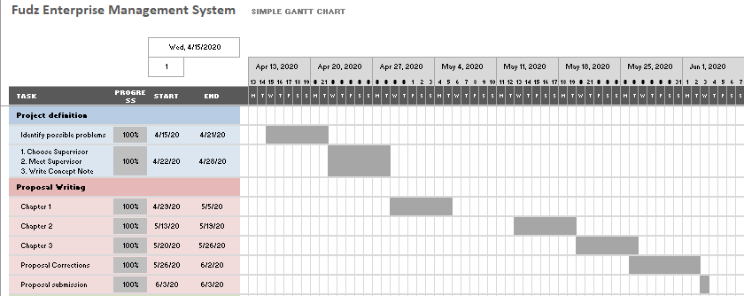

Appendix A..: Gantt chart